Tasks
1.
Create a comparison table listing at least 5 key differences between traditional WAN and SD-WAN, focusing on how data is routed, managed, and secured.
>
Feature | Traditional WAN | SD-WAN (Software-Defined WAN)
Data Routing | Packet-based & Rigid: Routes traffic based strictly on static routing tables, IP addresses, and fixed paths (typically sending everything through an MPLS circuit). | Application-aware & Dynamic: Routes traffic dynamically based on the type of application, real-time link performance, and defined business policies.
Management | Decentralized / Manual: Requires network engineers to configure each router individually via Command Line Interface (CLI). Changes take a long time to deploy. | Centralized Control: Managed from a single, centralized software controller orchestrating the entire network. Configuration updates are pushed instantly.
Security | Perimeter-based: Relies heavily on backhauling all branch traffic to a central data center firewall before letting it go to the internet. | Built-in / Native Security: Features built-in end-to-end encryption (IPsec tunnels), integrated next-generation firewalls at the edge, and secure direct internet access.
Cost & Transport | Expensive dependency on dedicated MPLS circuits; backup links sit completely idle. | Uses any combination of transport links (MPLS, Broadband, LTE/5G) actively at the same time, reducing costs.
Provisioning Time | Weeks to Months: Setting up a new branch office requires physical hardware deployments and manual provisioning by service providers. | Minutes / Zero-Touch: Supports Zero-Touch Provisioning (ZTP). Once the edge device connects to the internet, it pulls its configuration automatically.

2.
Draw a simple network diagram (on paper or using a tool like draw.io) showing how SD-WAN connects multiple branch offices to cloud apps (like Office 365 or AWS) and the main data center. Label the SD-WAN controllers, edges, and at least two types of WAN links (e.g., MPLS, broadband).
>

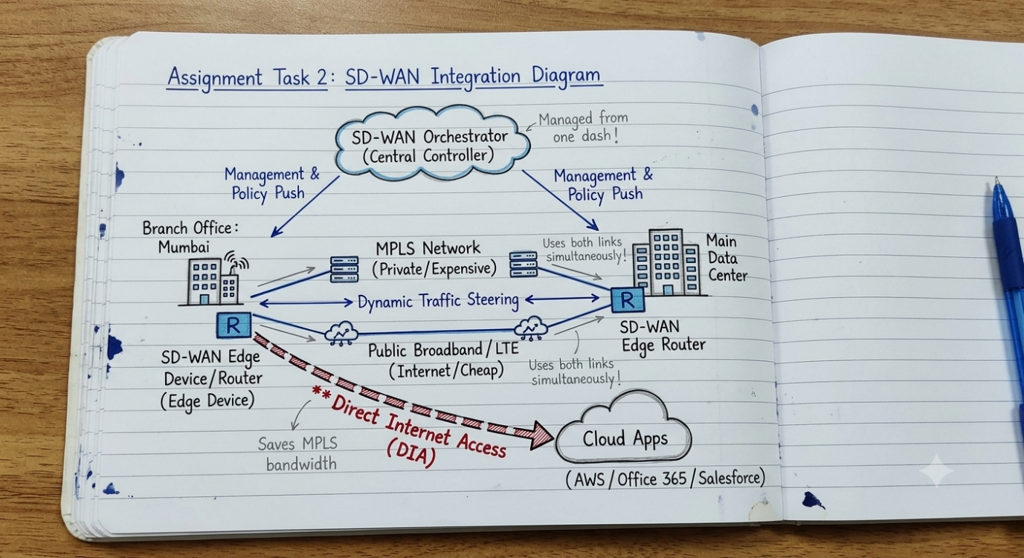

3.
Pick any app you use daily (like WhatsApp, Zomato, or Instagram) and write a short scenario explaining how SD-WAN could improve user experience for that app when used across multiple cities in India.<br><br><em><strong>Hint:</strong> Think about speed, reliability, and security when users access the app from different locations.</em>
>Let's pick Zomato as our daily-use app example and explore how SD-WAN would dramatically improve user and business operations across multiple cities in India (like Delhi, Mumbai, and Bangalore):
- Smart Traffic Routing (Application Awareness): Zomato handles different kinds of data simultaneously—live GPS tracking of riders, payment processing, image loading for restaurant menus, and internal database updates. SD-WAN recognizes these different data types. It prioritizes critical payment and real-time database transactions over stable paths, while pushing heavy image loading over standard, cheaper internet connections.
- Flawless Reliability (No Interruptions): If a major fiber internet line goes down in Mumbai during peak dinner hours, SD-WAN instantly switches user sessions to a backup line (like an alternate broadband provider or 5G backup link) in milliseconds. Users browsing menus or trying to order food won't experience dropped connections or failed checkouts.
- Lower Latency for Better Experience: Instead of routing all app traffic from a user in Bangalore back to a single central data center in North India, SD-WAN permits secure Direct Internet Access (DIA). The app can connect straight to the nearest local cloud server cluster (like AWS Mumbai/Bangalore), making the app feel incredibly fast and responsive.

4.
List and explain three key benefits of SD-WAN for a company with offices in Ahmedabad, Mumbai, and Bangalore. For each benefit, give a real-world example of how it would help employees or customers.
>
For a company operating with physical offices distributed across Ahmedabad, Mumbai, and Bangalore, implementing an SD-WAN architecture brings three massive operational advantages:
1. Active-Active Path Utilization & Cost Savings
- Explanation: In traditional networks, companies pay for an expensive primary MPLS link, and a secondary backup link sits completely idle doing nothing. SD-WAN allows the offices to use all available connections (MPLS, regular broadband, 4G/5G) at the exact same time.
- Real-World Example: The Bangalore development office can route heavy, non-critical daily data backups over cheap local broadband, while reserving the premium MPLS line exclusively for real-time executive video conferencing between Mumbai and Ahmedabad.
2. Centralized Management & Zero-Touch Provisioning (ZTP)
- Explanation: Network configurations do not need to be updated manually router-by-router. Everything is managed from a single central software controller dashboard.
- Real-World Example: If the company decides to open a brand-new branch office in Ahmedabad, the IT team doesn't need to fly an engineer down there. They simply ship a standard SD-WAN edge box to the office. A local staff member plugs it into the internet power line, and the device automatically pulls its entire configuration from the cloud in minutes.
3. Direct Internet Access (DIA) for Cloud Applications
- Explanation: Traditional setups force internet and cloud traffic to go back to the headquarters data center first (backhauling). SD-WAN allows individual offices to securely go straight to the internet for cloud apps.
- Real-World Example: Employees in the Mumbai branch office using cloud tools like Microsoft Office 365 or AWS do not have their traffic routed through the Ahmedabad headquarters. Their traffic goes directly out to the cloud locally, which eliminates lag and speeds up productivity tools.

